|  |  |
| --- | --- |
| **EX.N0 : 5** | **Implement programs for estimating & eliminating trend in time series data- aggregation, smoothing.** |
| **DATE : 20/03/2025** |

**AIM:**

# Implement programs for estimating & eliminating trend in time series data- aggregation, smoothing.

# ALGORITHM:

# Step 1: Import Libraries Step 2: Load the Dataset Step 3: Parse Dates & Set Index Step 4: Select Numeric Column Step 5: Plot Original Time Series Step 6: Trend Estimation using Aggregation Step 7: Plot Aggregated Data Step 8: Apply Moving Average Smoothing Step 9: Plot Smoothed Data

# PROGRAM:

import pandas as pd

import matplotlib.pyplot as plt

# Load the dataset

file_path = '/mnt/data/climate_change_data.csv'

df = pd.read_csv(file_path)

# Show column names and data types

print("Columns and Data Types:")

print(df.dtypes)

print("\nFirst few rows:")

display(df.head())

# Convert first column to datetime and set as index

date_col = df.columns[0]

df[date_col] = pd.to_datetime(df[date_col], errors='coerce')

df.set_index(date_col, inplace=True)

# Drop non-numeric columns for analysis

numeric_df = df.select_dtypes(include='number')

# Check if we have numeric data

if numeric_df.empty:

raise ValueError("No numeric columns found to perform trend analysis!")

# Choose the first numeric column for demonstration

value_col = numeric_df.columns[0]

print(f"\nUsing column '{value_col}' for trend analysis.")

# Plot original data

plt.figure(figsize=(12, 5))

plt.plot(numeric_df[value_col], label='Original Data')

plt.title('Original Time Series')

plt.xlabel('Date')

plt.ylabel(value_col)

plt.grid(True)

plt.legend()

plt.show()

# -------- Aggregation (monthly) --------

monthly_agg = numeric_df[value_col].resample('M').mean()

plt.figure(figsize=(12, 5))

plt.plot(monthly_agg, label='Monthly Aggregated', color='green')

plt.title('Trend Estimation using Aggregation')

plt.xlabel('Date')

plt.ylabel(value_col)

plt.grid(True)

plt.legend()

plt.show()

# -------- Smoothing (moving average) --------

window_size = 12

numeric_df['Smoothed'] = numeric_df[value_col].rolling(window=window_size).mean()

plt.figure(figsize=(12, 5))

plt.plot(numeric_df[value_col], label='Original')

plt.plot(numeric_df['Smoothed'], label='Smoothed (12-point MA)', color='orange')

plt.title('Trend Elimination using Moving Average')

plt.xlabel('Date')

plt.ylabel(value_col)

plt.grid(True)

plt.legend()

plt.show()

**OUTPUT:**

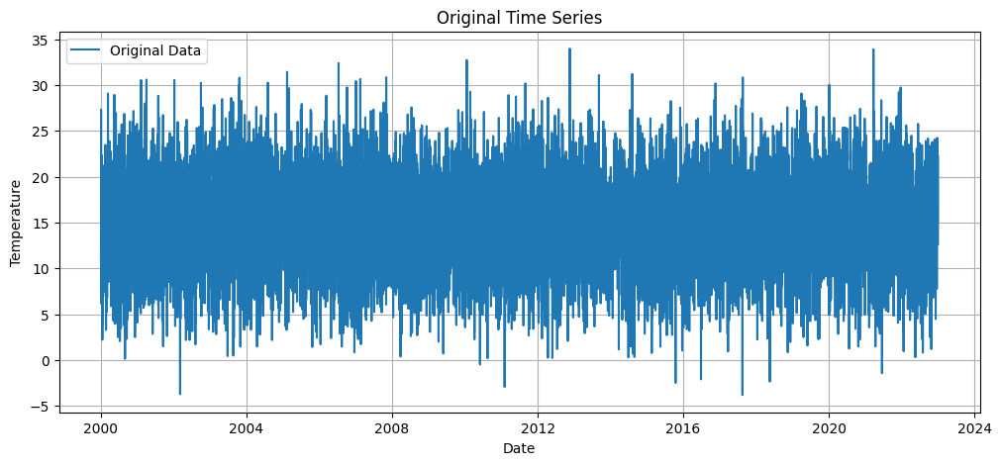

# RESULT:

Thus, the program for Implement programs for a time series data is executed successfully.